Beaumont Community Preschool
welcome pack

Registered Charity Number: 1050749 Ofsted Number: 109947
Website: https://beaumontpreschool.com facebook: Beaumont Preschool | Facebook

Our Team
Management Team
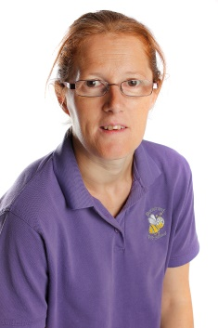
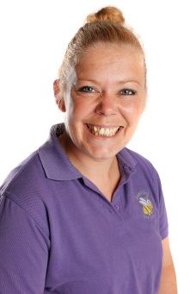

Nicole Breakwell (ba HONS) Kate Howard (ba hons)
Manager DEPUTY MANAGER

BUmbles room (ages 3 months to 3 years)
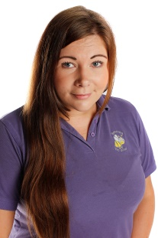
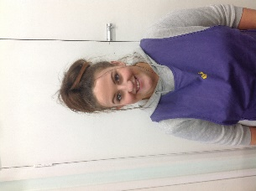

louise brenton ABBIE YOUNG
bumbles room leader
3rd in charge

Preschool ROom (Ages 3 yrs to 5 yrs)
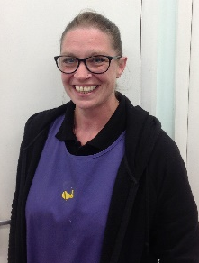
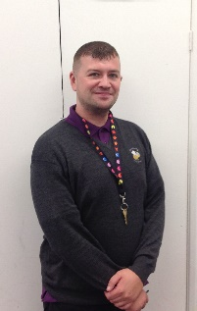
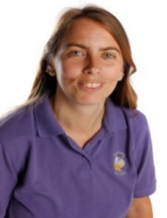
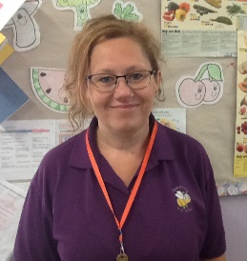

Victoria Busby chris whitehead toomey donachie Diane watts
preschool room leader deputy room leader
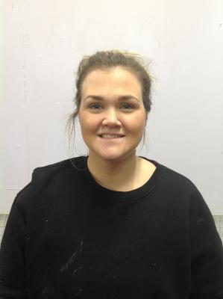
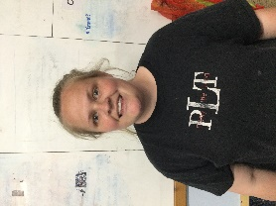

Olivia Watson Emily Robinson
Vision & Mission Statement
Our Vision
At Beaumont Community Preschool and Childcare groups our vision is families and practitioners working together to provide a safe, stimulating, and happy environment that offers positive learning experiences for children. At Beaumont, every individual is valued and respected. Practitioners encourage ’learning through play’ and try to see things through the child’s eyes to help each child reach their full potential.
Practitioners create and maintain a developmentally appropriate learning environment and actively encourage families to participate and enhance their child’s early education.
Guided by high expectations and with the knowledge that all children are unique and learn and develop at different levels and speeds, our team will provide a wide range of educational and fun opportunities based on the children’s interests that will support each child in learning to the best of his or her abilities.

Our Mission
At Beaumont Community Preschool and Childcare groups our mission is to offer a high standard of affordable care and education for children aged 3 months to 5 years in and around the local community. Our focus is building a foundation of families and practitioners working together to provide the best possible outcome for children.
By working with families our mission is to provide a safe, stimulating, and happy environment that enhances learning and provides positive experiences for each and every child, so that they can succeed and expand their own knowledge.
Our learning environment offers opportunities for children to develop at their own pace and to their full potential, by supporting them in building on their strengths and encouraging them to gain the skills necessary to prepare them for their next learning journey through school.

What your child will need
- Labelled changes of clothes/underwear.
- Labelled filled water bottle.
We encourage this to be water rather than juice. Once finished we will only refill with water.
- If your child will be having lunch, please provide a Healthy lunch provided in a named lunchbox (see lunch alternatives sheet for healthy ideas)
- If your child has milk bottles, please provide named readymade bottles formula milk/expressed.
- Nappies, wipes, and nappy cream or whichever your child may use i.e cotton wool, terry towelling’s, pants etc
- For the Bumbles room please provide your child with slippers (optional).
- Please ensure your child brings their comforter i.e dummy, blanket if necessary.
- Please bring any prescribed medication your child may need in the original box and hand it to a member of staff.
- Please do not allow your child to attend the setting wearing jewellery or fashion accessories that may pose a potential hazard to other children or themselves. (Please refer to Jewellery and accessories section within Health & Safety policy)
Cold Weather | Hot Weather
Suitable Jacket  Wellies  Hat, Scarf and Gloves | Sun hat (labelled)  Sun-cream to be applied prior to session but provide sun-cream to be applied if the child attends all day.

Lots of children tend to have similar/same items so please ensure that any items that you provide for your child are clearly labelled.
Please find link for ordering name tags from MyNameTags using school ID 41692 https://www.mynametags.com/affiliate?id=41692" title="Order page
Please note we aim to allow the children out in all weathers, children will not be restricted from going outdoors if they choose to do so, unless unsafe weather conditions.
Staff encourage children to wear aprons for ‘messy play’ and art/craft activities, but we cannot force the children if they choose not to, children will get dirty/wet and sometimes clothes can be stained.
To protect the clothes without inhibiting your child’s play and creativity, we ask you to dress your child in sensible ‘play’ clothes - not ‘best’ clothes.

The role of the key person
At Beaumont Community Preschool & Childcare Groups we believe that children settle best when they have a key person to relate to, who knows them and their parents well, and who can meet their individual needs. When your child first starts at Beaumont Community Preschool & Childcare Groups, they will be allocated a keyperson. The key person approach benefits the child, the parents, the staff and the setting by providing secure relationships in which children thrive, parents have confidence, staff are committed, and the setting is a happy and dedicated place to attend. Your child’s keyperson will be your first point of contact if you need anything.
Settling In
To feel securely settled and ready to learn, children need to form attachments with the adults who care for them, primarily a key person, but others too. In this way they feel part of a community; they are able to contribute to that community and receive from it. Very young children, especially two- to three-year-olds, approach separation from their parent with anxieties, older children have a more secure understanding of ‘people permanence’ and are able to approach new experiences with confidence; but also need time to adjust and feel secure. It is the entitlement of all children to be settled comfortably into a new environment.
We arrange the settling in process in conjunction with the parent/carers prior to your child officially starting within the setting, these are flexible dependant on the situation, age, stages and ability and the child’s/families’ individual needs.

dROPPING OFF & Collecting Your Child
- On arrival staff members will collect your child from the main gate, we believe children build independence by entering the setting independently. If your child struggles, we will discuss this with you and make a plan that best suits the child.
- When you arrive, please let staff know of any relevant information that may affect your child’s day such as if your child hasn’t slept, any injuries occurred since last session, so we are able to fill an existing injury form, if your child hasn’t had breakfast, if they have had any illnesses etc since last attending.
- Parents must ensure to collect their child at the required end of session times, if you are going to be late, we ask that you contact us as soon as possible. We do follow a late collections policy which states that if your child is continually collected later than 5 minutes on 3 or more occasions there is a £10.00 late charge, which may increase by £5 for every 10 minutes thereafter
- Please be advised that after 30 minutes we have a duty of care to contact Children’s Services following our Child Protection and Uncollected child procedures
- Children will only be allowed to leave the setting with persons stated on the collection list (Registration form) unless we have had prior notice given. The password given on registration will need to be used by persons unknown to us and on the first initial pick up we also ask that they provide identification. *Please be aware this is part of our safeguarding procedures and is put in place to keep your child safe.
- Please always inform us of any changes to your details including persons allowed to collect and any contact details including emergency contacts.
- No one under the age of 16 will be allowed to collect your child.
- No one will be allowed to leave the setting with your child if they are believed to be under the influence of alcohol or drugs if they are believed to be driving a motor vehicle, in this case the police will be called.
Healthy eating
At Beaumont Community Preschool we promote and encourage healthy eating within our provision by offering suitable food and drink which meet children’s nutritional needs
Promoting healthy eating in an early year setting provides an assurance to parents or carers that their child's nutritional wellbeing is being taken care of. It helps children settle into a new environment as good eating habits are established and is associated with improved learning and behaviour.
Within our setting we advise parents/carers to not provide unsuitable lunchbox items such as too many sugary, salty and fatty foods and foods such as sweets, chocolate, cakes and children are not to be provided with fizzy drinks.
As a setting we are committed to meeting children’s dietary requirements and allergies, and we ask parents/carers to not put in foods containing nuts.
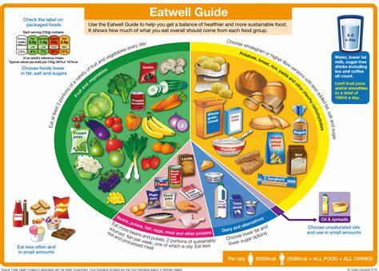

Lunch box alternatives ideas

Food ideas | Drink Ideas
- Varieties fruits kiwi, pineapple, mango, strawberries, apples, banana, grapes, melon, raspberries, blueberries, oranges, satsumas, peaches/nectarines or a mixture as a fruit salad with a spoonful of yoghurt  - Lower sugar muesli bars. (But check label as some can be high in sugars, maybe try making your own at home)  - Carrot, cucumber, celery stick with low fat yogurt or houmous dip.  - Boxes of raisins and other dried fruit.  - Cooked pasta/noodles  - Filled pitta breads, bread roll, naan, chapatti, bagel, tortilla/wrap, potato cake, malt loaf, hot cross bun, and scone.  - Rice Cakes/Oatcakes  - Yogurt  - Cheese you could add crackers you could also use low fat cheese spread.  - Tomatoes, peppers  - Bread sticks with cheese dips.  - Baked Crisps  - Low sugar jelly  - Mixed Salad  - Croissants, teacakes  - Samosa, pakora, spring roll  - Cold rice pudding or custard  - Cottage cheese with pineapple  - Flapjack, shortbread (why not try making this together at home)  - Homemade pizza with vegetable toppings (Get your child to help you create it) | Please ensure no glass bottles are brought into the setting.  - Fruit smoothies (Get your child to help you create it)  - Water  - Milk  - Pure fruit juice  - Very diluted pure fruit juice  - Sugar free cordial  - Milkshake
Foods to avoid-
- Shop bought microwave meals/ready meals as these contain a high quantity of salt.
- No fried foods
- No meats on the bone.
- No pot noodles, super noodles
- No fruit shoots, Ribena, fizzy drinks as these have a high sugar content.
- No tea or coffee.
- No sweets
- No doughnuts
- Minimal chocolate products
- We are a nut free setting and do not allow nuts/nut products at any time this includes chocolate spreads, pesto.
- Lunchables/attack a snacks on a daily basis.
Did you know that all these count as your 5 a day?
- 100 % pure unsweetened orange juice (only one glass a day counts) or Fresh fruit smoothies
- A small handful of currants and raisins, dried apricots
- Tinned peaches in natural juice (not syrup)
- Tinned tomatoes and Tinned sweetcorn or handful of frozen peas
- Pure fruit juice iced lollies
- Vegetable soup
- Baked beans and kidney beans
Childcare costs
- We offer the Universal 15-hour free universal funding. Based on eligibility criteria we also offer 30-hour funding and 2-year-old funding.
- We are also registered with the Tax-Free Childcare scheme and also accept childcare vouchers if these are provided through your workplace
- Please refer to our Admissions, Fees and Funding policy for more information
- For more information on childcare cost help please visit Childcare Choices | 30 Hours Free Childcare, Tax-Free Childcare and More | Help with Costs | GOV.UK

Policies and procedures are available upon request and are available on our website, we do ask parents to read them so that you are aware of how our setting runs and what we do. https://www.beaumontpreschool.com
SAfeguarding Children
At Beaumont Community Preschool & Childcare Groups the welfare of the children within our care is of paramount importance and we will aim to do everything we reasonably can to fulfil our ‘duty of care’ towards any children. Staff take any concerns seriously and will report any matter immediately to the Designated Safeguarding Leads.
- Within our provision we have awareness of various aspects of safeguarding and the vulnerabilities children may have. The setting will record and monitor such things but not limited to.
- Existing Injuries- This is where a child arrives at the setting where there is an injury that has not occurred within the setting.
- Potential signs of abuse.
- Disclosures – This is where a child may disclose information that could mean that they are at risk of harm and may require a report to be made to Children’s Services.
- Children’s Non-Attendance - (Please refer to Children’s Absence policy)
- Prevent Duty – This is where there may be signs of radicalisation or extremism.
Further information can be found in our Safeguarding Children and young people policy.

The Early Years Foundation Stage Framework (EYFS) is a curriculum that sets out the learning and development stages for children as they grow from birth to five years. Children develop more rapidly during the first five years of their lives than at any other time. For those working in the early years (whether as a childminder or in a nursery, pre-school, or reception class in school), the Early Years Foundation Stage framework outlines what practitioners need to do to support your child. (Please see attached EYFS information document). Please also visit What-to-expect-in-the-EYFS-complete-FINAL-16.09-compressed.pdf (foundationyears.org.uk) for ‘What to expect in the Early Years Foundation Stage: a guide for parents’.
Early Years Foundation Stage

Assessing and Recording your child’s learning and development

We assess children based on the guidance of the Development Matters in line with the Early Years Foundation Stage, these assessments play an important part in helping parents, carers and practitioners to recognise children’s progress, understand their needs, and to plan activities and support. Ongoing assessment is an integral part of the learning and development process. It involves practitioners observing children to understand their level of achievement, interests and learning styles, and to then shape learning experiences for each child reflecting those observations.
We record your child’s learning via our secure electronic learning journeys called ‘Tapestry’ for more information visit https://tapestry.info/ .
Parents/carers are also encouraged to become involved in building up their child’s learning journey by adding their own observations of their child’s development, events they may be involved in, special occasions or anything that you would like to share with us.
Once your child begins with us, they will be added to Tapestry, and you will receive an activation link sent to your provided email address where you can set up your own personal access password. You may also allow other people such as family members that can also have access to your child’s account. (More information about Tapestry is within the Tapestry guide and agreement)

2-year checks
(Please refer to 2-year check information document)
The two-year progress check is a short, written summary of a child’s development in the three prime areas of learning and development. It takes place when a child is between the ages of two and three (24 to 36 months).

The aims of the two-year progress check are to:
• ensure that parents and carers have a clear understanding of their child’s development.
• describe any actions childcare providers intend to take to address any developmental concerns, including working with other professionals where appropriate.
• identify the child’s strengths and any areas where progress is less than expected

“Play is essential for children’s development, building their confidence as they learn to explore, to think about problems, and relate to others. Children learn by leading their own play, and by taking part in play which is guided by adults.” (EYFS)

Special Educational Needs & Disabilities
The term SEN support defines arrangements for identifying and supporting children with special educational needs and/or disabilities. We are required to offer appropriate support and intervention and to promote equality of opportunity for children that we care for.
Within the setting we carry out a graduated approach:
- Initial identification and support (identifying special educational needs)
- Use observation and assessment of children’s SEN - Where a child appears to be behind expected levels, or their progress gives cause for concern, practitioners consider all the information about the child’s learning and development from within and beyond the setting.
- Planning intervention - A first intervention option may be to carry on with applying differentiated support and to review the child’s progress at an agreed date. If the child’s needs are more complex, then the decision maybe to go straight ahead and prepare SEN support: plan with detailed evidence-based interventions being applied straight away and simultaneously external referrals made.
Local Offer includes Information and services available in Hampshire for children and young people (birth to 25) who have Special Educational Needs and/or Disabilities (SEND).
Beaumont Pre-School | Family Information and Services Hub (hants.gov.uk)
Parent Consultations
We usually hold Parent’s evenings three times a year, during this time your child’s keyperson will talk to you about your child’s learning and development. Your child’s next steps will also be agreed and discussed with you, as well as giving you the opportunity to give your own views/comments and contribution.
If you are unable to attend, we can arrange a suitable time with you however although we hold these consultations Beaumont Community Preschool & Childcare Groups has an open-door policy where you can discuss your child’s learning and development at any time.

If you have any concerns or your child has additional needs these will be discussed, and an individual education plan created or reviewed. The setting has Inclusion Officers who liaise with other agencies to provide the best tailored support for you and your child.

Louise – Bumbles Rooms Tori – Preschool Room

Information Sharing
At Beaumont Community Preschool & Childcare Groups we promote parental involvement and sharing of information between practitioners and our families within the setting, we ask that you keep us informed of any changes that may affect your child however small such as behaviour changes, bereavements including loss of a pet, births, moving to a new home or even something new that they have done i.e new skill, starting a club or going on holiday etc these are things we can talk to your child about and support them if needed.
We will regularly send out our Stories from home sheet where you can share what your child has done i.e on holiday or things you have done over the half terms etc, we also have available Proud Clouds if there is anything that you would like to share i.e your child has started using a potty, learning a new word, swimming for the first time etc.
We will update you and share information through daily communication of what your child has done, for under two’s you will be given a daily sheet that has information such as nappies, what they have played with or eaten. We will also communicate through half termly newsletters, Parentmail, noticeboards and signs, Facebook and Parent’s Evenings
Beaumont Community Preschool follows the General Data Protection Regulations (GDPR) in all information sharing and handling/storage of data. We are registered with the ICO – Reference - ZA427378. (Please see our Data Protection Policy/Information Sharing policy for more information.
ABsences, Illnesses and Medication
- If your child is unwell, please where possible inform the setting prior to their session starting and inform us of the reason why just in case we need to inform other parent’s i.e., contagious illness.
- If your child has had sickness or diarrhoea, they must not attend the setting until 48 hours after the last episode and if your child becomes unwell within the session, we will contact you.
- If a child has not had a medication before, especially a baby/child under two, we ask that the parent keeps the child at home for the first 48 hours to ensure no adverse effect as well as to give time for the medication to take effect.
- The setting has a list of excludable diseases and current exclusion times. The full list is obtainable from www.gov.uk/government/publications/health-protection-in-schools-and-other-childcare-facilities and includes common childhood illnesses such as measles. Some contagious diseases within the excludable list do not require an exclusion period however the setting reserves the right to not admit children with contagious diseases to safeguard children and minimise the risk to other children and their families.
- Medications will only be given if they are prescribed by a doctor (unless in emergency situations with consent) and the relevant documents have been completed. Please inform us if your child has been given medication prior to arriving at the setting. We do ask where possible if medication is required to be taken 3 times a day that this is carried out at home as far as possible administering medicines will only be carried out where it would be detrimental to the child’s health if not given in the setting.
- If your child will be absent due to going on holiday, please where possible let us know in writing as soon as possible with start and end date.
- Please note that if you pay fees, you will still be required to pay whether your child is sick or on holiday and no alternative days can be given as these are staffed for in advance.
- We are a nut free setting and ask that parents/carers do not allow your child to enter the setting with anything containing nuts.
- If your child has an allergy or intolerance, we will accommodate this through our snack menus, but we do ask, if possible, to provide items such as soya milk, free from butter. If this is not possible, please speak to a member of staff.
- If your child has an allergy or intolerance where they could require emergency treatment, we ask you to provide us with details so that we are able to create a health care plan for your child.
- We keep details of all the allergens that may be contained within the food products purchased by the setting.
Please refer to the settings Policy on Administering Medicines and Managing children who are sick, infectious or with allergies which are available on request or on our website.

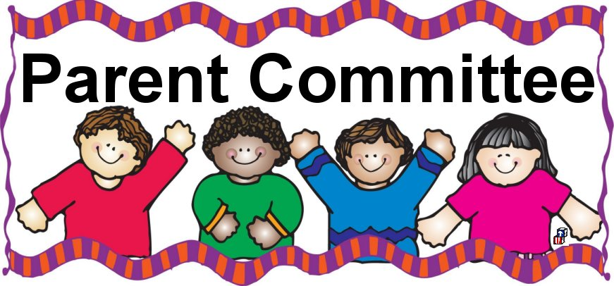
Committee
As a charity parent run setting it is necessary for us to have a structure of parents and other trusted community members who form our settings committee.
We rely on parents coming together to keep our setting open without you this could not happen, you can support us by becoming part of the parent committee where you can meet other parents and be involved in decisions that are made for the setting.
You can be involved as little or as much as you like such as the settings Chairperson, Secretary or Treasurer or be part of fundraising and events or simply by just giving your ideas and maybe volunteering your time for example to help within the rooms, do some baking with the children or helping out with outings.
Volunteering
All parents/carers are always welcome to volunteer within the setting to come and share a story, special talent, share your cultural backgrounds or a particular job role that you may have, please speak to a staff member if this is something you would like to do.
Making a complaint or raising a concern
Beaumont Community Preschool & Childcare Groups believes that children and parents are entitled to expect courtesy and prompt, careful attention to their needs and wishes. We welcome suggestions on how to improve our setting and will give prompt and serious attention to any concerns about the running of the setting. We anticipate that most concerns will be resolved quickly by an informal approach to the appropriate member of staff. If this does not achieve the desired result, we have a set of procedures for dealing with concerns. We aim to bring all concerns about the running of our setting to a satisfactory conclusion for all the parties involved. (Please refer to Making Complaints policy for process)
Who to Talk to in the setting?
Your child’s Key Person is your first point of contact. You can also speak to Tori, the Pre-School Room Leader or Louise, Bumbles Room Leader, if you have any questions or concerns.
Louise and Tori are also the setting Inclusion officers (special educational needs co-ordinator).
Nicole and Kate (Management) are the designated Safeguarding leads.
If you have questions about administration – forms, funding, fees etc - please speak to the managers Nicole and Kate.
You can also speak to the Chair of our Parent Committee.
General information

- We are a NON-SMOKING setting which includes Vapes/E-Cigarettes.

- No mobile phones or recording devices are allowed to be used onsite at any time by parents/carers. Children are not permitted to wear smartwatches or bring in mobile phones into the setting.

- We do not allow parking onsite, please park respectfully and be thoughtful of our neighbouring properties.

- Does my child have to be toilet trained?
No, we encourage potty and toilet training when your child is ready, and we follow whatever routine you are doing at home to help with continuity of care.
- Does my child need to wear a uniform?
Children do not need to wear a uniform and just need to come in clothes that are suitable for messy play! However, we do have t-shirts and sweatshirts for sale at the Pre-school throughout the year if you would like your child to wear a uniform.

Prices – Logo Jumpers we have ages 3-4yrs or 5-6yrs at £12 each
Logo T-shirts we have ages 3-4yrs and 5-6yrs at £9 each

- Can my child bring in toys?
We prefer if children keep their own toys at home as these can cause disagreements and may get broken, however we understand that children have comfort toys. If your child needs to bring a toy in to avoid distress this will be placed in their bag during their session

Beaumont Community Preschool & Childcare Group’s
Privacy Notice

Data Protection Officer: Nicole Breakwell (Manager)

Introduction
Beaumont Community Preschool & Childcare Groups are committed to ensuring that any personal data we hold about you and your child is protected in accordance with data protection laws and is used in line with your expectations.

This privacy notice explains what personal data we collect, why we collect it, how we use it and how we protect it.

What personal data do we collect?
We collect personal data about you and your child to provide care and learning that is tailored to meet your child’s individual needs. We also collect information to verify your eligibility for funded childcare as applicable.

Personal details that we collect about your child include:
- your child’s name, date of birth, address, health and medical needs, development needs, and any special educational needs

Where applicable we will obtain child protection plans from social care and health care plans from health professionals.

We will also ask for information about who has parental responsibility for your child and any court orders pertaining to your child.

Personal details that we collect about you include:
- your name, home and work address, phone numbers, emergency contact details, and family details

This information will be collected from you directly in the registration form.

If you apply for up to 30 hours funded childcare, we will also collect:
- your national insurance number or unique taxpayer reference (UTR) if you’re self-employed. We may also collect information regarding benefits and family credits that you are in receipt of.

Why we collect this information and the legal basis for handling your data
We use personal data about you and your child to provide childcare services and fulfil the contractual arrangement you have entered into. This includes using your data to:
- contact you in case of an emergency
- to support your child’s wellbeing and development
- to manage any special educational, health or medical needs of your child whilst at our setting
- to carry out regular assessment of your child’s progress and to identify any areas of concern
- to maintain contact with you about your child’s progress and respond to any questions you may have
- to process your claim for up to 30 hours funded childcare (only where applicable)
- to keep you updated with information about our service

With your consent, we will also record your child’s activities for their individual learning record. This may include photographs and videos. You will have the opportunity to withdraw your consent at any time, for images taken by confirming so in writing.
We have a legal obligation to process safeguarding related data about your child should we have concerns about their welfare. We also have a legal obligation to transfer records and certain information about your child to the school that your child will be attending (see Transfer of Records policy).

Who we share your data with?
In order for us to deliver childcare services we will also share your data as required with the following categories of recipients:
- Ofsted – during an inspection or following a complaint about [my/our] service
- banking services to process chip and pin and/or direct debit payments (as applicable)
- the Local Authority (where you claim up to 30 hours funded childcare as applicable)
- the government’s eligibility checker (as above)
- our insurance underwriter (if applicable)
- our setting software management provider (if applicable)
- the school that your child will be attending

We will also share your data if:
- We are legally required to do so, for example, by law, by a court or the Charity Commission.
- to enforce or apply the terms and conditions of your contract with us.
- to protect your child and other children; for example, by sharing information with social care or the police.
- it is necessary to protect rights, property or safety
- We transfer the management of the setting; in which case we may disclose your personal data to the new chair so they may continue the service in the same way.

We will never share your data with any other organisation to use for their own purposes

How do we protect your data?
We protect unauthorised access to your personal data and prevent it from being lost, accidentally destroyed, misused, or disclosed by:
Storing hard copy data in a secure locked cabinet at our setting
Storing electronic data in a secure password protected personal computer under the guardianship of our office manager and management.

How long do we retain your data?
We retain your child’s personal data for up to 3 years after your child no longer uses our setting, or until our next Ofsted inspection after your child leaves our setting. Medication records and accident records are kept for longer according to legal requirements. Your child’s learning and development records are maintained by us and sent to you via tapestry when your child leaves unless otherwise requested.

In some instances (child protection, or other support service referrals) we are obliged to keep your data for longer if it is necessary to comply with legal requirements (see our Children’s and Provider Records policies).

Your rights with respect to your data
You have the right to:
- request access, amend or correct your/your child’s personal data
- request that we delete or stop processing your/your child’s personal data, for example where the data is no longer necessary for the purposes of processing; and
- request that we transfer your, and your child’s personal data to another person

If you wish to exercise any of these rights at any time or if you have any questions, comments or concerns about this privacy notice, or how we handle your data please contact us. If you have continued to have concerns about the way your data is handled and remain dissatisfied after raising your concern with us, you have the right to complain to the Information Commissioner Office (ICO). The ICO can be contacted at Information Commissioner’s Office, Wycliffe House, Water Lane, Wilmslow, Cheshire, SK9 5AF or ico.org.uk/

Changes to this notice
We keep this notice under regular review. You will be notified of any changes where appropriate.
Oct 2021

