Information for parents / carers:
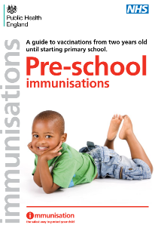
We have listed our recommended messages about vaccinations for you to share with families. Many are great links to include in a parent email or newsletter, others could be printed and displayed on a noticeboard. Alongside health professionals such as Health Visitors, early years settings play a key role in helping promote the importance of childhood vaccinations to parents and carers. It helps protect the child and their family, and everyone else in the setting too.
Pre-school immunisations guide: Comprehensive NHS and Public Health England online leaflet containing details of immunisations for children aged 2 to 5 years, before they start school. Contains common questions asked, information about pre-school immunisations, watch out for meningitis and septicaemia, and travel advice.
Immunisations babies up to 13 months of age guide: Comprehensive NHS and Public Health England online leaflet containing details of immunisations for children up to one year.
What to expect after vaccines leaflet: This NHS leaflet tells you about the common side effects of vaccinations that might occur in babies and young children up to 5 years of age (Available in a range of languages).
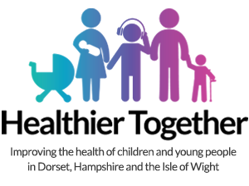
The NHS has created a great webpage with lots of information about vaccinations. This is helpful for both early years practitioners and parents/carers to explore and helps everyone understand what’s involved. They have written about Vaccination appointment tips and Myths about Children’s vaccinations - perfect for parents who might be a bit worried or unsure and would benefit from more information.
Webpage: Wessex Healthier Together vaccination essential information. A local website full of information about health concerns for parents/carers and professionals.
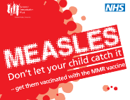
Poster: Starting school immunisation reminder
Poster: Starting nursery immunisation reminder
Poster: Measles don’t let your child catch it
Parent Tips 1 and Tips 2 from the Institute of Health Visiting about immunisation
Blog: 14 questions new parents ask about vaccination, five minute read
Video: Vaccines and you child’s immune system film
Video: Flu Heroes – Nasal Flu Spray for Kids
FAQs about vaccines eg. 'What happens if I decide not to get my child vaccinated and then change my mind?'
A parent/carer can change their mind at any point. Even though it is better to get a child vaccinated at the ages recommended in the UK schedule, it is never too late to start vaccination. The majority of vaccines can be given at any point in childhood, so parents/carers can make an appointment with their practice nurse to discuss getting their child the vaccines they need.

Got a parent with lots of questions about vaccination? They can ask a health visitor using ChatHealth for Parents (0-5 years). A confidential secure text messaging service. Text the dedicated number 07520 615720.

