Allergen List
Item | Allergen
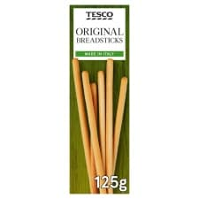  Breadsticks | Wheat
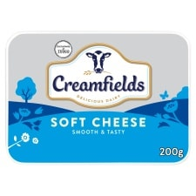  Soft Cheese | Milk
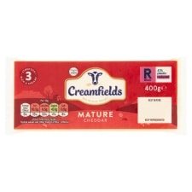  Cheese | Milk
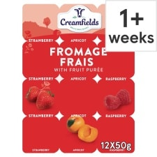  Yogurts | Milk
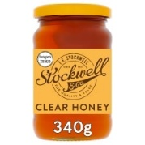  Honey | Only for children over 1 years old
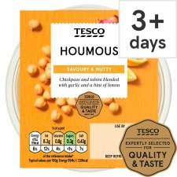  Houmous | Sesame Seed
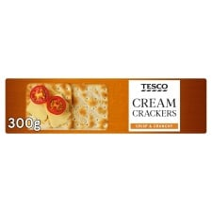  Cream Crackers | Wheat
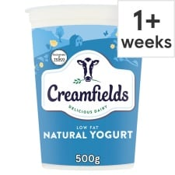  Natural Yoghurt | Milk
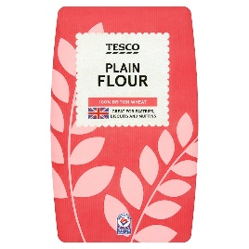 | Wheat
Item | Allergen
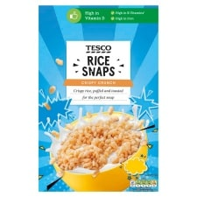  Rice Snaps Cereal | Barley
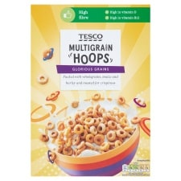  Multigrain Hoop Cereal | Wheat, Oat, Barley
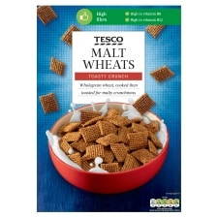  Malted Wheat Cereal | Wholewheat, Barley
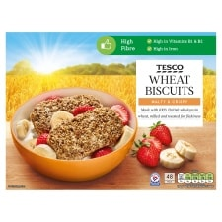  Wheat Biscuits Cereal | Barley
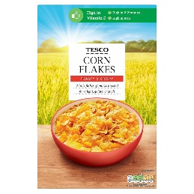  Cornflakes | Barley
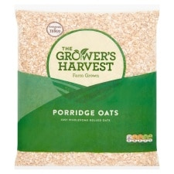  Porridge Oats | Oats
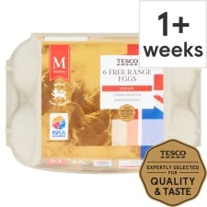  Eggs | Egg
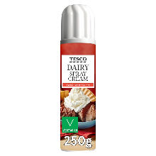 | Milk
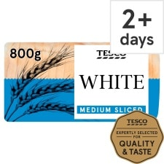  White Bread | Wheat and Soya
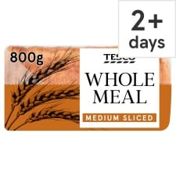  Wholemeal Bread | Wheat and Barley
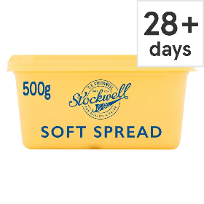  Soft Spread | None
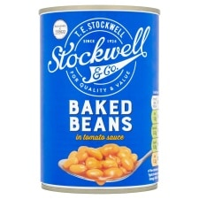  Baked Beans | None
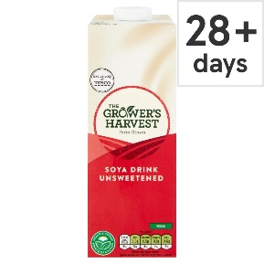  Soya Milk | Soya
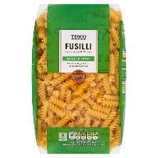  Dried Pastas | Wheat

