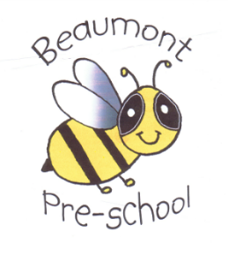

Beaumont Community Preschool & Childcare Groups
Oral health
The setting provides care for children and promotes health through promoting oral health and hygiene, encouraging healthy eating, healthy snacks and tooth brushing.
- Fresh drinking water is available at all times and easily accessible.
- Sugary drinks are not served.
- In partnership with parents, babies are introduced to an open free-flowing cup at 6 months and from 12 months are discouraged from using a bottle.
- Only water and milk are served with morning and afternoon snacks.
- Children are offered healthy nutritious snacks with no added sugar.
- Parents are discouraged from sending in confectionary as a snack or treat.
Where children clean their teeth when at the setting
- Children are encouraged to brush their teeth as part of the daily routine.
- Each child has their own toothbrush, which is stored individually to prevent accidental contact and cross contamination.
- A small amount of toothpaste is put onto a paper towel before applying to the brush to prevent cross contamination.
- Toothbrushes are cleaned at each session and sterilised weekly in Milton or similar disinfecting fluid.
- Toothbrushes are changed every three months.
- Oral hygiene activities are included in planning every three months when toothbrushes are changed.
- The setting co-ordinates with local oral health and ensure procedures are reviewed regularly, additional guidance from the local team may be added to this procedure.
Pacifiers/dummies
- Parents are advised to stop using dummies/pacifiers once their child is 12 months old.
- Dummies that are damaged are disposed of and parents are told that this has happened
Further guidance
Infant & Toddler Forum: Ten Steps for Healthy Toddlers www.infantandtoddlerforum.org/toddlers-to-preschool/healthy-eating/ten-steps-for-healthy-toddlers/

This policy was adopted at a meeting of | Beaumont Community Preschool & Childcare Groups
Held on |  | (date)
Date to be reviewed |  | (date)
Signed on behalf of the management committee
Name of signatory
Role of signatory (e.g. chair/owner)

