Information for Parents/Carers: Oral (dental) Health
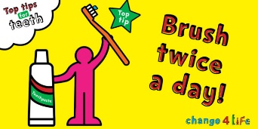
A quarter of 5-year olds in England have tooth decay when they start school. Tooth decay is largely preventable. Poor oral health can affect children’s ability to sleep, eat, speak, play and socialise with other children. Parents and carers can help children look after their teeth.
NHS Advice Taking Care of Children’s Teeth
NHS Advice Drinks and Cups for Babies and Young Children
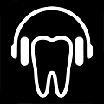
NHS-approved App: Brush DJ Timer https://www.brushdj.com/
Sugar Smart facts https://www.nhs.uk/change4life/food-facts/sugar
Change4Life Low Sugar Drinks and Sugar Food Facts
A practical guide to children’s teeth leaflet by the British Society of Paediatric Dentistry
Looking after your Children’s Teeth factsheet by the Institute for Health Visitors
Visit the Wessex Dental Advisory Service for help finding a local dentist
Problems finding an NHS dentist
If after contacting several dental surgeries you still cannot find a dentist accepting NHS patients, call NHS England's Customer Contact Centre on 0300 311 2233.
NHS England commissions dental services in England and is required to meet the needs of their local population for both urgent and routine dental care.
Your local Healthwatch also may be able to give you information about services in your area.
Dental emergency and out-of-hours care
If you think you need urgent care, contact your usual dentist as some surgeries offer emergency dental slots and will provide care if clinically necessary.
You can also contact NHS 111, who can put you in touch with an urgent dental service.
Do not contact a GP, as they will not be able to offer urgent or emergency dental care.

